**Naincy Thapa**

**IT-520**

**LAB 6**

**03-29-2019**

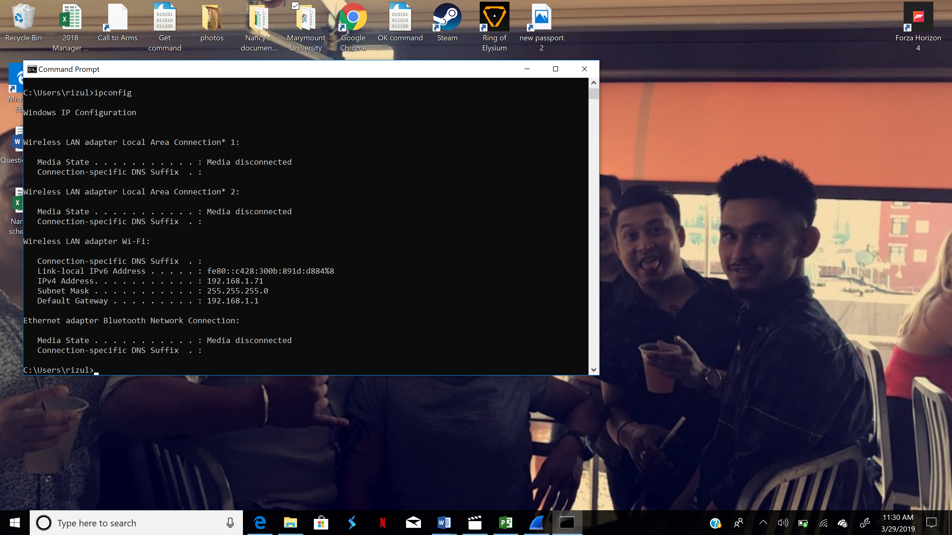



1. What is the MAC address from your computer?

**B4:6B:FC:6B:FE:A9**

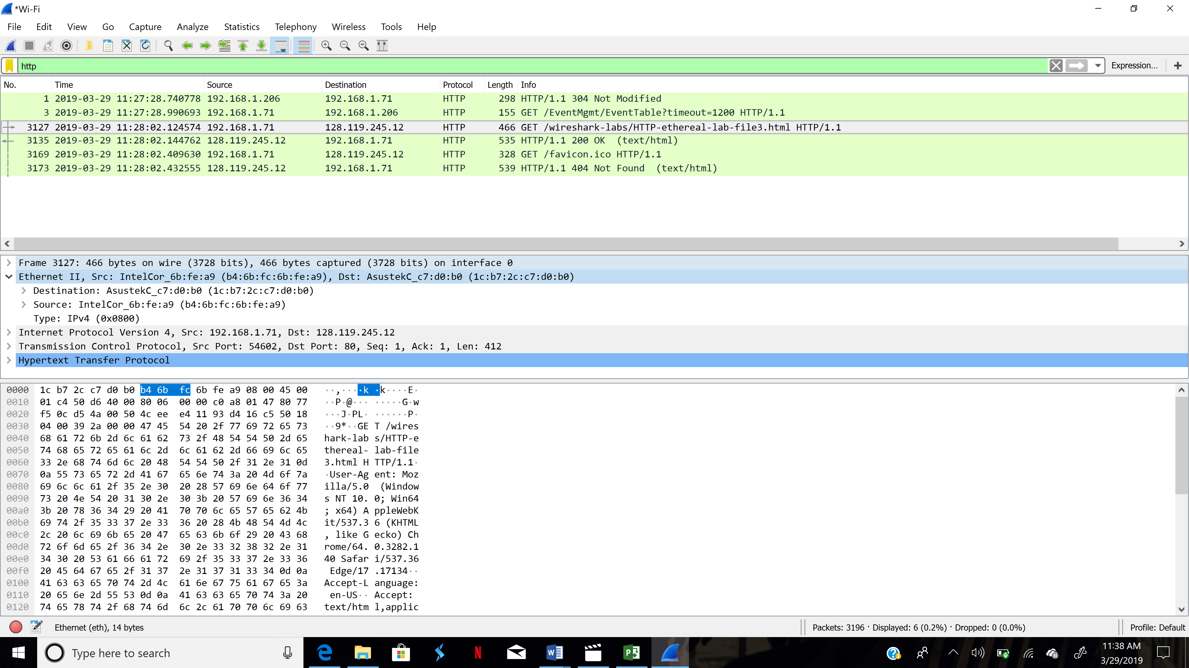



1. What is the destination MAC address?

**1C.B7.2C.C7.D0.B0**

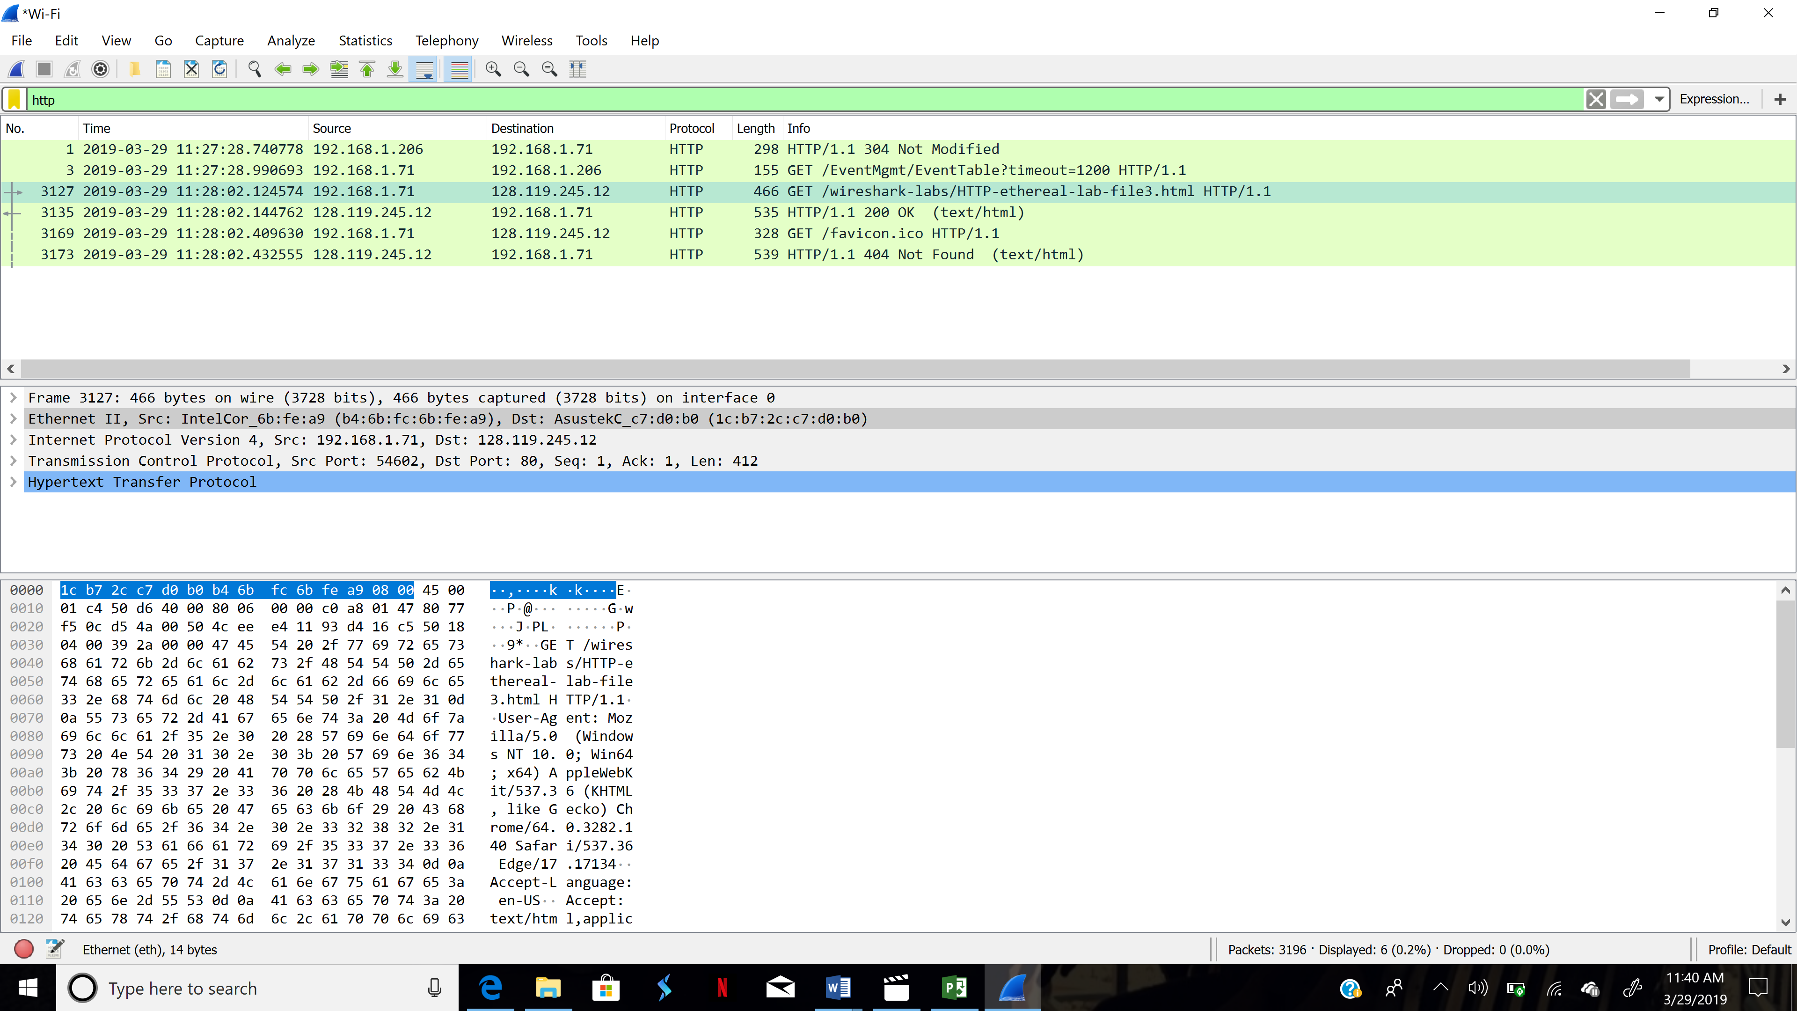



1. What device has the MAC address shown in the destination?

**AsustekC_c7**

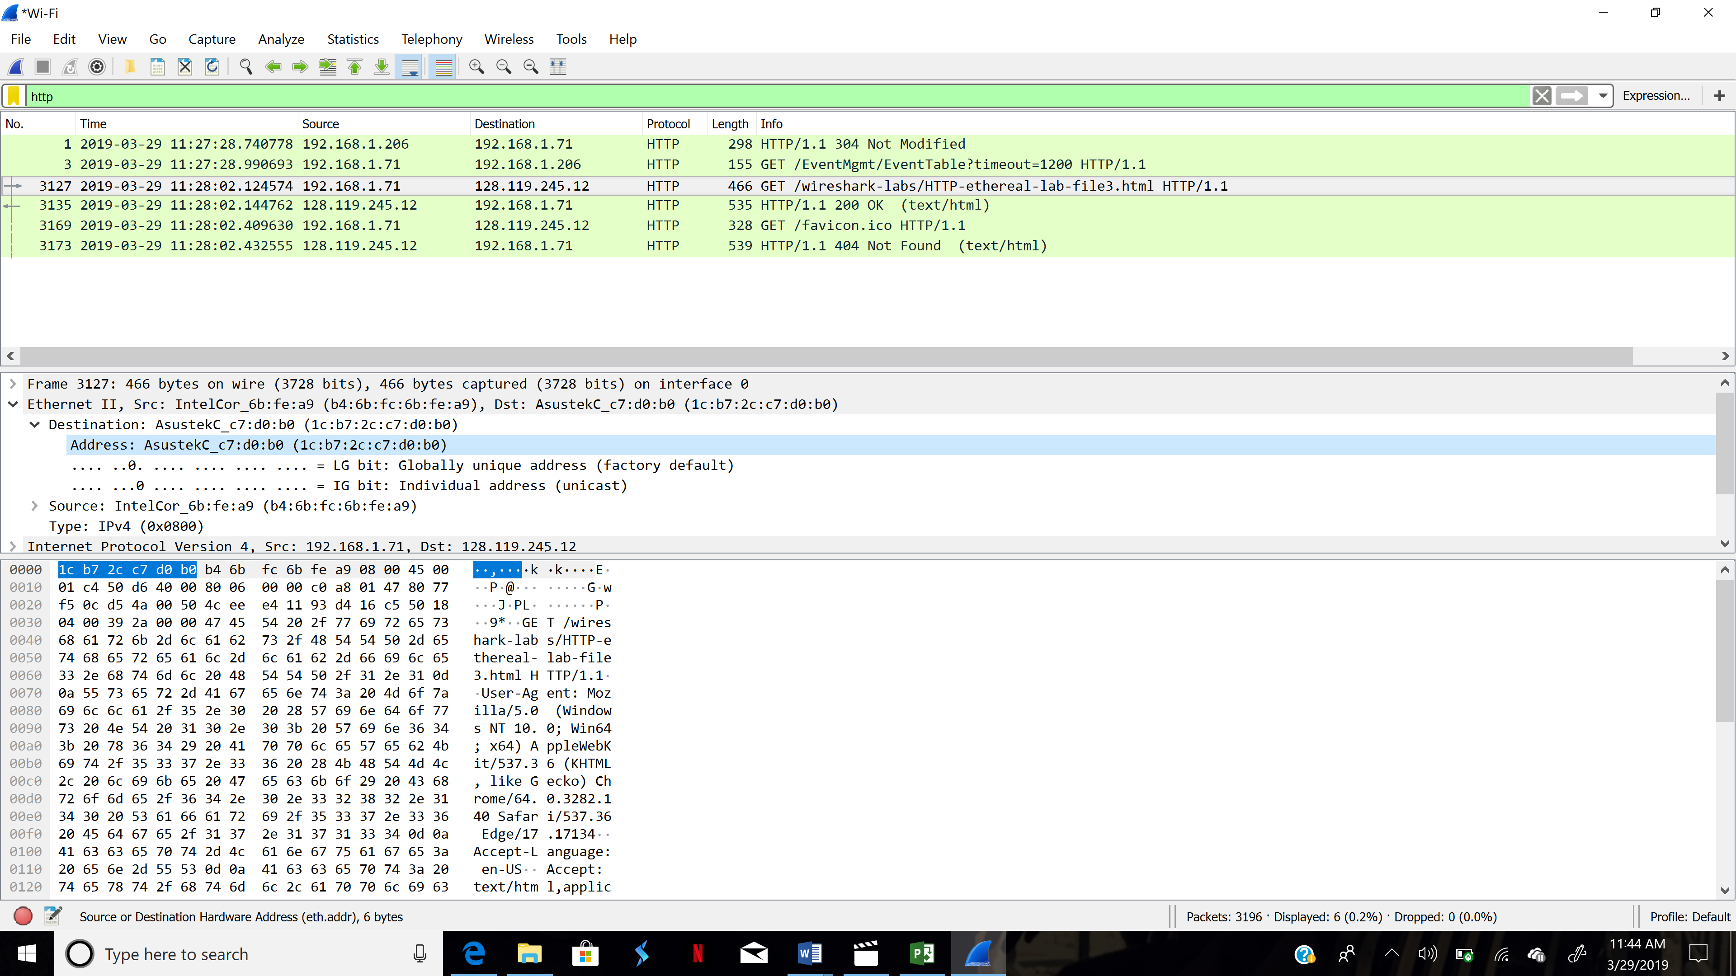



1. Explain the relationship between the destination MAC address and the destination IP address.

**The destination MAC address only shows the MAC address of the router connected to the source which will later send the data to another router or the destination. The destination IP address belongs to the server that we are trying to access rather than the middle routers.**

1. Using the terminal (cmd in Windows, Terminal in mac), run a command to display your full ARP list table. (Find out what the command is, and print a full screen shot of your result.)

**arp -a**

